**Experiment 2 : Arduino UNO - Read digital and analog signal from a sensor module**

**Aim:** The principal aim of this experiment is to interface a sensor with the microcontroller and to experiment with its analog and digital values..

**1. COMPONENTS REQUIRED**

1. Arduino UNO
2. Breadboard
3. soil moisture sensor
4. Jumper wires

a. ARDUINO UNO:

Arduino UNO is a microcontroller board based on the ATmega328P. It has 14 digital input/output pins (of which 6 can be used as PWM outputs), 6 analog inputs, a 16 MHz ceramic resonator, a USB connection, a power jack, an ICSP header and a reset button. It contains everything needed to support the microcontroller; simply connect it to a computer with a USB cable or power it with a AC-to-DC adapter or battery to get started. You can tinker with your UNO without worrying too much about doing something wrong, worst case scenario you can replace the chip for a few dollars and start over again.

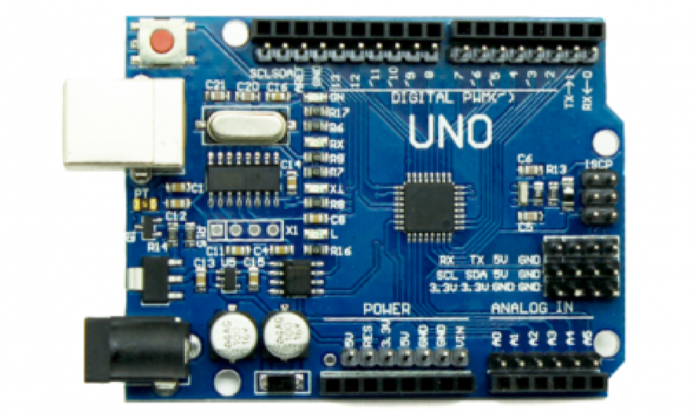

Figure 1.0 - Arduino UNO

b. BREADBOARD:

Breadboards are one of the most fundamental pieces when learning how to build circuits. Breadboards are commonly utilized while prototyping temporary circuits. It is useful to designers because it allows components to be removed and replaced easily.

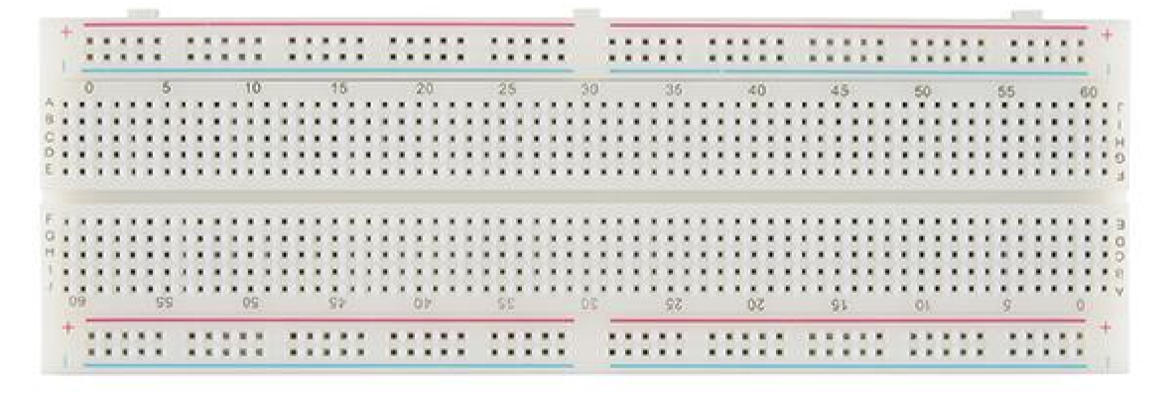

Figure 1.1 – Breadboard

**c. soil moisture sensor :**

The soil moisture sensor is the first thing that springs to mind when it comes to building your smart irrigation system or automatic plant watering system. With this sensor in place and a little Arduino support, we can design a system that can water your plants when it's needed, avoiding overwatering and under watering.

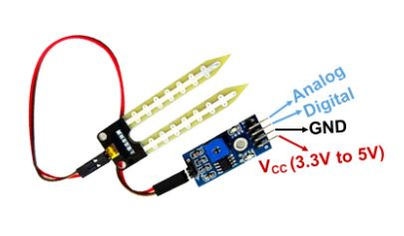

**d.** **WIRING**

**●** Connect the “vcc” of the sensor to the “5v” of the Arduino UNO, GND to GND pin of the microcontroller, D0 pin to the D8 pin of the microcontroller, and A0 to the A0 pin of the microcontroller..

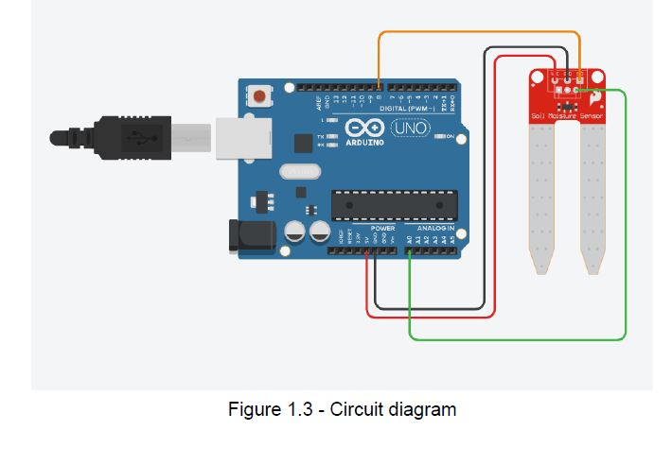

**2.SOFTWARE**

Software is a generic term to refer to the scripts and programs that run on a microprocessor or microcontroller and execute specific tasks.

2.1 GET START WITH ARDUINO IDE

Follow the steps to install Arduino IDE:

Step 1: Browse for the URL - ' https://www.arduino.cc/en/software '

Step 2: In DOWNLOAD OPTIONS, choose Windows/Linux/Mac OS accordingly.

Step 3: Select - JUST DOWNLOAD. The download will start!

Step 4: Run the downloaded setup file.

**3. PROGRAM to implement Read digital and analog signal from a sensor module.**

void setup() {

 pinMode(8,INPUT);

Serial.begin(9600);

}

void loop() {

  int soil_digital_value = digitalRead(8);

  int analog_value = analogRead(A0);

Serial.print(soil_digital_value);

Serial.print("  ");

Serial.println(analog_value);

**4. Results**

Fetched the data successfully from the sensor using the microcontroller unit in both analog and digital form